Van Lang University

Software Measurement and Analysis course

**Employee Satisfaction Report**

**Version number:** 1.0

**Author:** K14T01 – Team 01

**Team member:**

Duong Nguyen

Mung Nguyen

Manh Nguyen

Binh Huynh

Hien Nguyen

**Table of Content**

1. **Introduction 1**
2. **Employee Satisfaction Measurement 2**

1. **Employee Satisfaction Report 2**
2. **Recommendations 4**

**List of figures**

*Figure_1. Positive Chart*

*Figure_2. Adverse Chart*

**List of tables**

*Table_1. The employee satisfaction trend data*

1. **Introduction**
   1. **Purpose of document**

* This document is to specify the method to analysis employee survey data that provided by employee and specify the strengths and weaknesses in this survey.
* The document also shows the areas for improvement for the survey.
* Through this document we will suggest recommendations that would you make to improve the survey.
  1. **Overview background**
* In order to assess employee satisfaction, we rely on the statements around the key aspects of employee satisfaction, such as job satisfaction, career promotion, environment, communication, etc.
* The statements based on a Strongly Agree, Agree, Neutral, Disagree, Strongly Disagree scale. The following show the key aspects and related statements:

1. **Job satisfaction**
   * + I am currently looking for another job outside of ABC Systems
     + I would recommend ABC Systems to friends as a great place to work
     + I take pride in my work
2. **Environment**

* I am provided with opportunities to broaden my skills and knowledge
* My department is a great place to work
* ABC Systems is a great place to work
* My project is a great place to work
* I have the tools and resources that I need to get my job done

1. **Communication**

* I feel informed about changes that affect me
* There is cooperation between the departments in the company
* I have access to the information that I need to do my job well
* I know how my work contributes to the success of ABC Systems

1. **Career promotion**

* I see career growth and advancement opportunities for myself at ABC Systems

1. **Recognition**

* I am empowered to make decisions
* My opinions are valued by my project team

1. **Training and development**

* I have had the training I need to get the job done

1. **Employee Satisfaction Measurement**

* We will collect satisfaction index data based on 6 key aspects that is provided in Section 1, then calculates employee satisfaction index (ESI) in ABC System.
* *The* *satisfaction index of the key aspects is calculated by the total number % (Strongly Agree and Agree) at each of statement in key aspect.*

*The satisfaction index of the key aspect is considered positive when total number % (Strongly Agree and Agree) of key aspect more than 65%*

* *Employee Satisfaction Index (ESI) formula:*

|  |
| --- |
| *Total % positive of key aspects*  ESI =  *# Number of key aspects* |

* ESI > 65% - is considered positive
* ESI < 65% - is considered adverse

1. **Employee Satisfaction Report**

To collect the information contained in this report, 150 employees were invited to complete a survey - a total of 150 employees completed the questionnaire, which represents a participation rate of 100%.

To analysis detail, refer to *Employee Satisfaction Analysis 2010.xls*

***Report Summary:***

* *The overall in year 2010,*
* The satisfaction index of **job satisfaction** factor is 57% positive (< 65% in benchmark) and 47% of employees are looking another job outside of ABC System. The overall, job satisfaction level at ABC System is low.
* The satisfaction index of **environment** factor is 46% positive (<65% in benchmark). The environment satisfaction level is low at ABC System.
* 46% of employees can see opportunities for career development comes from ABC System. The satisfaction index of **career promotion** factor is low at ABC System (46% actual < 65% in benchmark).
* The satisfaction index of **communication** factor is 41% (<65% in benchmark). Compared with the benchmark, most employees are least satisfied with communications at ABC System.
* The satisfaction index of **recognition** factor is 46% (<65% in benchmark). This means that 46% of employees feel that they are recognized by their coworkers and their managers. However, the satisfaction index of **recognition** factor is still low at ABC System.
* 49% of employees are satisfied with the training and development in ABC System. However, the satisfaction index of **training** factor is still slow at ABC System (<65% in benchmark) when we compare with the benchmark.
* The **Employee Satisfaction Index** in 2010,

|  |
| --- |
| 57% + 46% + 46% + 41% + 46% + 49%  = 47%  ESI =  *6* |

**ESI is 47% (< 65% in benchmark) – most employees are not satisfied with ABC System.**

* Based on the above analysis, the areas for improvement for the survey is: (all key aspects)
  + Job Satisfaction
  + Environment
  + Communication
  + Career Promotion
  + Recognition
  + Training and development
* *The* *employee satisfaction trend from 2009 to 2010,*

|  |  |  |  |  |
| --- | --- | --- | --- | --- |
| **Key Aspects** | **2009** | | **2010** | |
| **Positive** | **Adverse** | **Positive** | **Adverse** |
| Job satisfaction | 0.64 | 0.19 | 0.57 | 0.22 |
| Environment | 0.49 | 0.28 | 0.46 | 0.31 |
| Communication | 0.45 | 0.32 | 0.41 | 0.36 |
| Career promotion | 0.43 | 0.37 | 0.46 | 0.35 |
| Recognition | 0.45 | 0.26 | 0.41 | 0.28 |
| Training and development | 0.58 | 0.28 | 0.49 | 0.35 |

*Table_1.* *The employee satisfaction trend data*

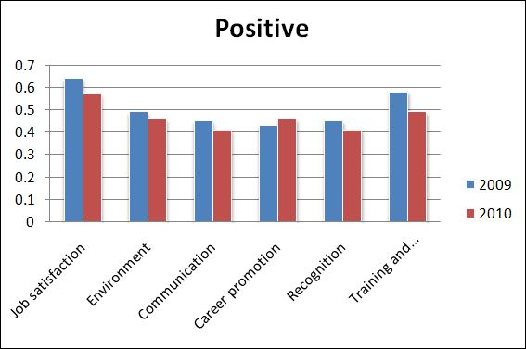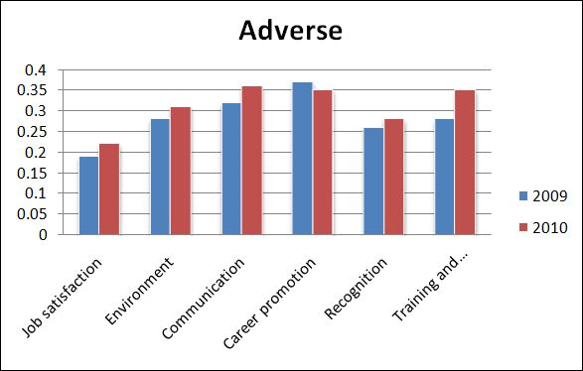

*Figure_1.* *Positive Chart Figure_2.* *Adverse Chart*

* In the figure_1. **Positive Chart**
  + - The blue columns show the % **positive** of the satisfaction index of key aspects in 2009
    - The red columns show the % **positive** of the satisfaction index of key aspects in 2010
    - Most of the length of the blue columns are **more longer than** red columns
  + **The positive is decreased** from 2009 to 2010
* In the figure_2. **Adverse Chart**
  + - The blue columns show the % **adverse** of the satisfaction index of key aspects in 2009
    - The red columns show the % **adverse** of the satisfaction index of key aspects in 2010
    - Most of the length of the blue columns are **more shorter than** red columns
  + **The adverse is increased** from 2009 to 2010
* The **Employee Satisfaction Index** in 2009, ESI = 51% (> 47% in 2010)
  + **The employee satisfaction is increased from 2009 to 2010**

1. **Recommendations**

* We need to classify statements in the areas (key aspects).
* The survey needs more than 2 statements into area, the employee can be reflect employee satisfaction more.
* In current, the survey has only 6 areas. We can add some others area, such as:
  + Benefit
  + Management
  + Work Life
  + Etc.